**CSCI 520L**

**Programming Assignment #4**

To be done in the lab

(Friday, Sep. 19, JOUR 102, 2:30-4:10pm)

Turn in your work in the drop box for Assignment 4 (for Week 4).

Simulate an array by a linear linked list:

Let A be an array that stores up to n (n=100 here) integers. We will use a linked list L to represent A. Your task is to write a C++ program that simulates operations on A by using L, and outputs results.

The following is an example snapshot of L and A at some given time:

int A[8]; A[1]=5; A[3]=2; A[4]=1; A[6]=7

/* node definitions for L */

struct node {

int index;

int data;

node* next;

};

typedef node *link;

AGAIN ASSUME THAT THE LIST DOES NOT CONTAIN MORE THAN 100 ELEMENTS

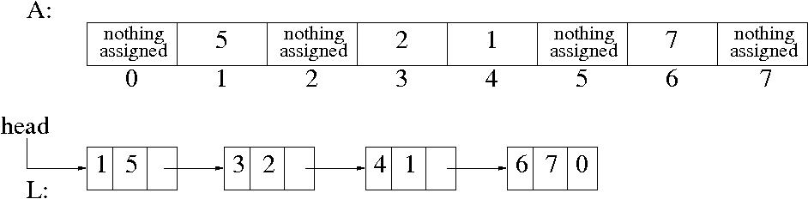

Do the following operations on L (the operations are defined on A; we need to perform equivalent operations on L):

HERE WE IMAGINE OPERATIONS ON A, BUT ACTUALLY DO THEM ON L, AND ALL ELEMENTS IN THE LIST ARE DISTINCT

A i x : Set A[i]=x

T : Output all data values in A (only the final assigned value, other parts are not used in A)

R: Resets A. All elements are reset meaning that there is no data in A.

Sample input/output:

A 1 5

A 3 4

A 4 1

A 6 7

A 3 2

T

index: 1 value: 5

index: 3 value: 2

index: 4 value: 1

index: 6 value: 7

R

A has been reset

T

No data in A now

A 1 5

T

index: 1 value: 5